Project: Eating a Rose Petal
Difficulty: Level 1

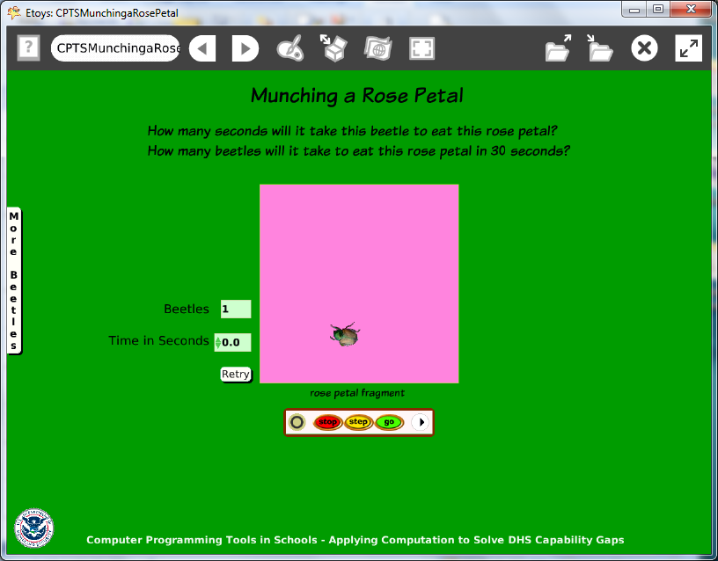

Time: Two 45 minute labs

Challenge:
Model the voracious appetite of a common pest beetle in your area for local vegetation and compare the time it takes one beetle and more beetles to eat a given amount of vegetation.

Programming:
Basic script tiles, random number tiles, a conditional statement, a declared variable, sibling copies, watchers

Things you’ll need to know:
Use a playfield from Supplies to represent the food or plant.
Quick Guides
- Paint Tools/ All
- Halo Handles/All
- Supplies: All Scripts Button, Text, Add a New Flap
- Object Catalog: Lasso Tool, Digital Images
- Script Tiles: Forward by, Turn by, Bounce Motion, Random Numbers,
Pen Use
- Menus: Viewer Icon Set (for information about how to declare a new variable), Normal Ticking, Button Fires a Script, Watchers, Scriptor Icons Set

Things to think about:
- Why is a playfield used?
- What is the effect of adding random numbers to the forward and turn tiles?
- One of script is set to “Normal”, why?
- What happens if you have ten beetles moving?
- How many beetles does it take to overwork your computer?

Extensions:
- Research news articles about insect pests in your area. Use current information to modify this project or to make a new one.
- This models a behavior but is not an accurate representation of size and scale of the rose and beetle. What else do you need to know to make a more accurate model?

NETS for Students:
http://www.iste.org/standards/nets-for-students/nets-student-standards-2007.aspx
1. Creativity and Innovation: a, b, c, d
2. Communication and Collaboration: b
3. Research and Information Fluency: b, c, d
4. Critical Thinking, Problem Solving, and Decision Making: a, c
5. Digital Citizenship: a
6. Technology Operations and Concepts: b, c

CSTA:
CSTA Level II: Objectives and Outline
http://csta.acm.org/Curriculum/sub/CurrFiles/L2-Objectives-and-Outlines.pdf
Level II objectives for middle school students are furthered through studying a programming language well enough that the student is proficient with it. Whether the language is Etoys, StarLogo TNG, or Scratch, it is the ability to use the language to express ideas that is valuable. A student skillful enough to use any programming language to express ideas, solve problems, model behaviors, simulate data, or to educate or entertain is an entitled person in today’s society.
Topics of particular note are:
Topic 2: Problem Solving
Topic 6: Connections between Mathematics and Computer Science
Topic 11: Programming Languages
Topic 13: Multimedia

Common Core Standards Mathematics:
http://www.corestandards.org/the-standards/mathematics
6. EE.2, 6.EE.5, 6.NS.2, 6.SP.1
7. EE.3
8. F.1, 8.F.4

Teacher Notes:
Materials: Provide students with a folder with images of beetles or other insects that affect food supply either in the field, food distribution chain, a restaurant or at school or home.

Comments: The scripts are not difficult but there are many decisions that take time and thought.
Declaring a variable called time could start a discussion of the use of variables in programming.

A tip to stop runaway scripts; the User interrupt function uses three keystrokes: Caps Lock -Alt -Apostrophe
Objects – Scripts – Decisions:
Insect image: Select insect, use a lasso tool to remove unwanted background
Script 1 has forward by and turn by tile s modified with random number
Variables
Pen trail set to true, select color of trail and pen size
Sibling copies made using the green halo handle. Hold down shift to make copies with the exact same script as the original. NB Changing the script for any sibling changes the script for all of them.
Script 2 is a reset script that clears trails and assigns a start location.
Playfield: represents plant or food, resize and recolor. Use the playfield’s collections watcher when ad
World: Script 1 uses a variable called stopwatch
Script 2 is a reset script that clears pen trails and sets the stopwatch to 0.

Example Scripts:

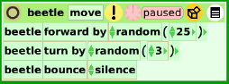
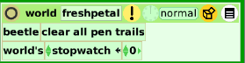
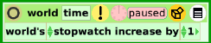
Student Notes:
None provided.

